SIRCLO Marketplace Monitor
State Documentation & System Architecture Walkthrough

1. Executive Summary & North Star
SIRCLO Marketplace Monitor is a real-time analytics web dashboard built for Brand Account Managers managing multiple brands across Shopee and TikTok Shop during midnight mega-sale campaigns (e.g., 10.10). During flash sale rushes, high order volumes and stacked vouchers routinely cause accidental below-cost selling (jual rugi), while marketplace channel stock runs out even when central warehouses still hold ample inventory. By replacing the 45-minute manual Google Sheets VLOOKUP process with instant multi-format data ingestion (<2 seconds), the tool detects profit leaks, forecasts stockout times, and enables 1-click WhatsApp escalation to operations.

2. State 01: Initial / Empty Dashboard View
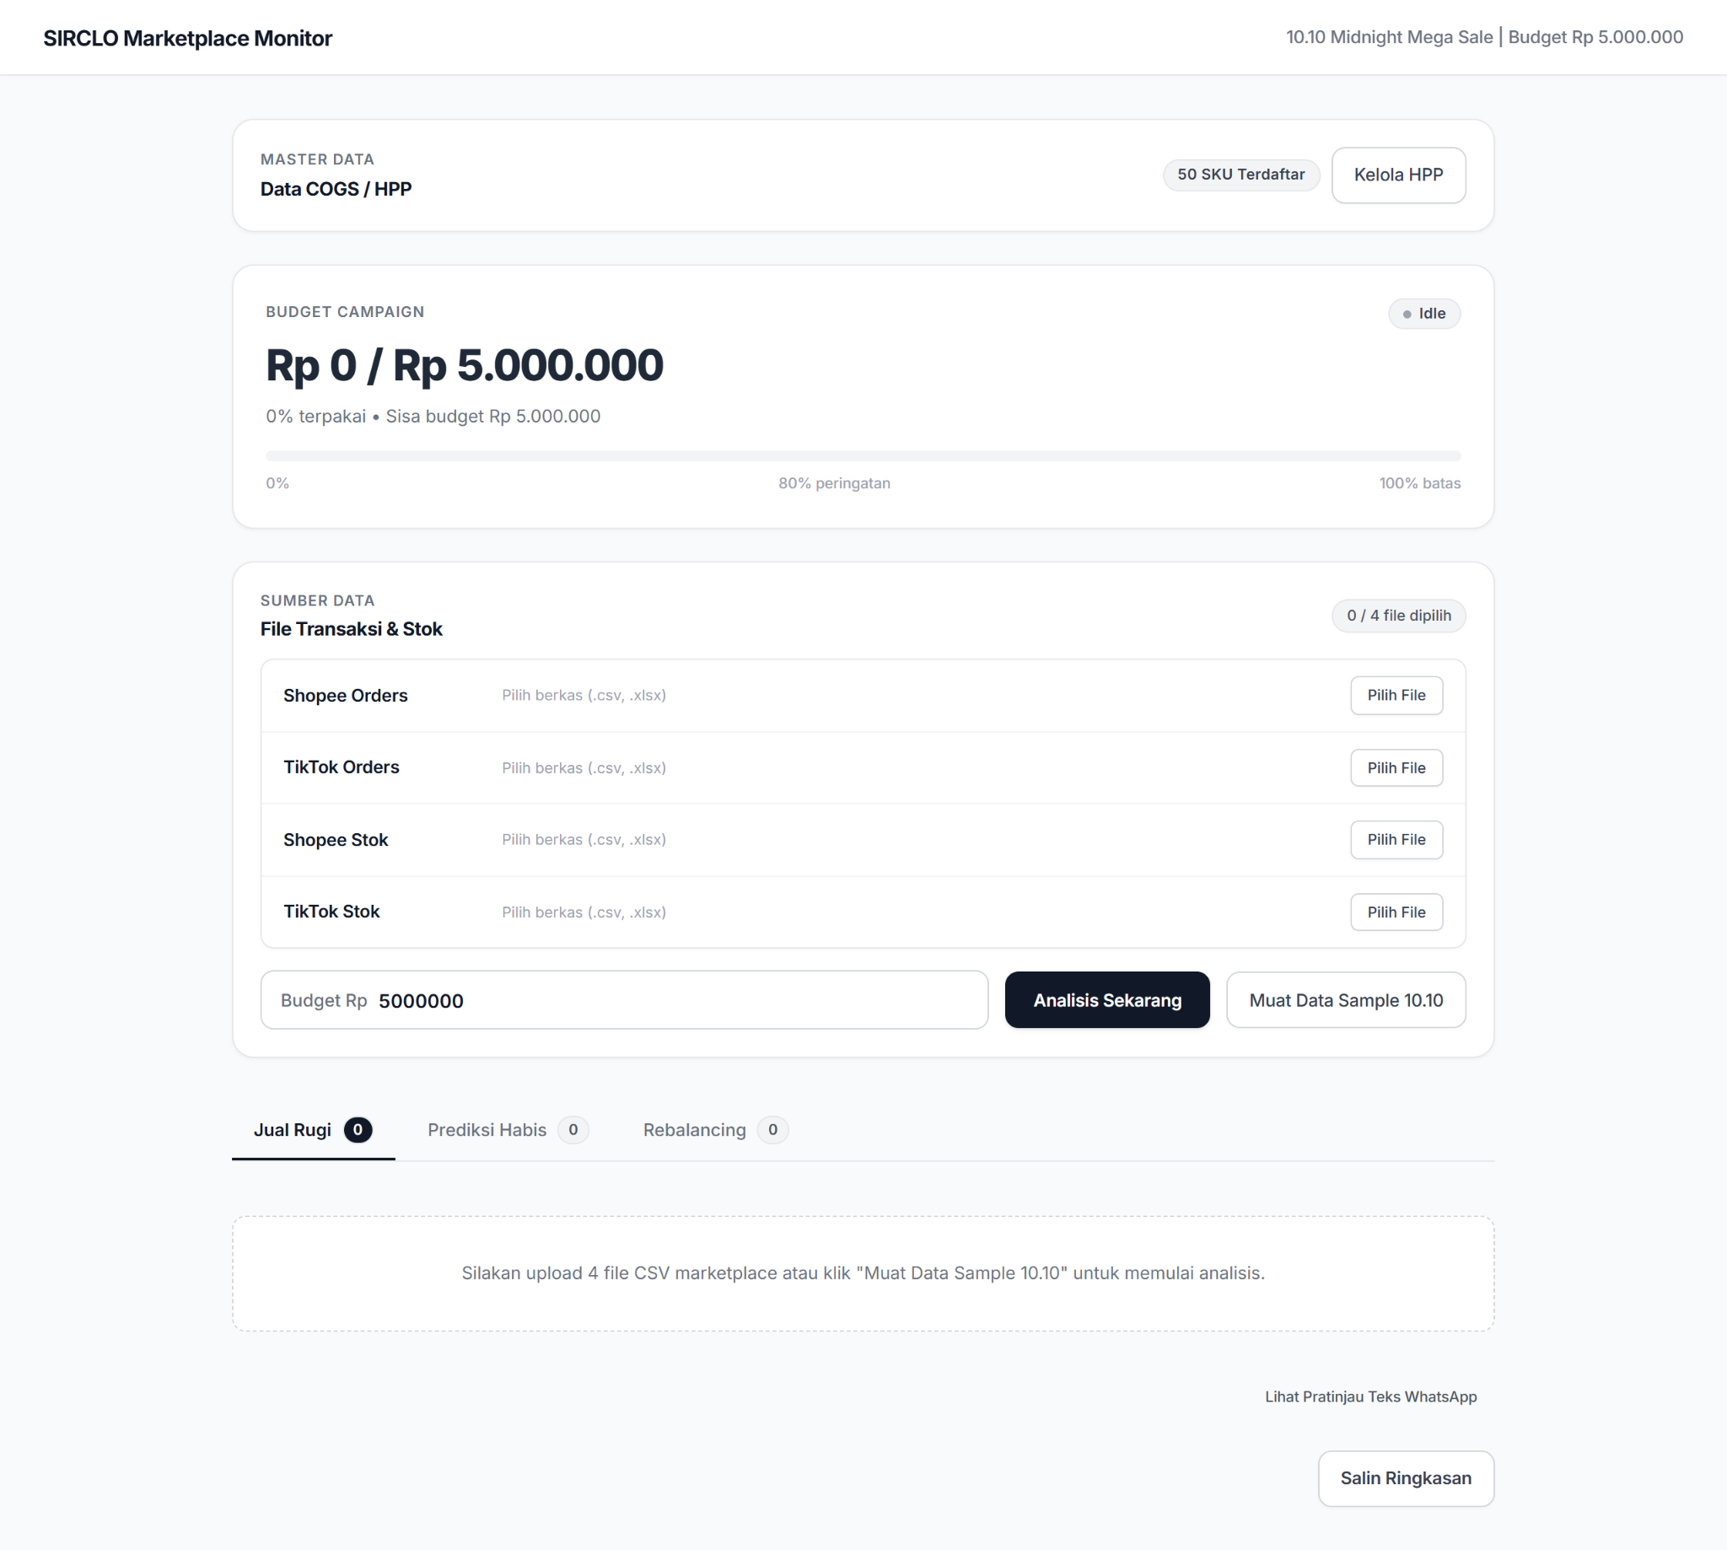
How It Works & Key Elements:
• Clean Aesthetic & No-Emoji Policy: Uses an uncluttered Stripe/Vercel design system with semantic status dots and tabular typography (Inter).
• Multi-Format Dropzones: Four distinct upload slots (Shopee Orders, TikTok Orders, Shopee Inventory, TikTok Inventory) accept CSV, Excel (.xlsx, .xls), and TSV without requiring manual spreadsheet conversion. Numeric cleaners automatically handle Indonesian thousand separators (e.g. '129.000').
• Campaign Budget Setup: Allows setting campaign budget parameters (default Rp 5.000.000) for real-time loss tracking.
• Instant Prototype Demo: The [Muat Data Sample 10.10] secondary action immediately populates realistic 10.10 campaign transaction data for zero-barrier testing.

3. State 02: Master Data Management (COGS / HPP)
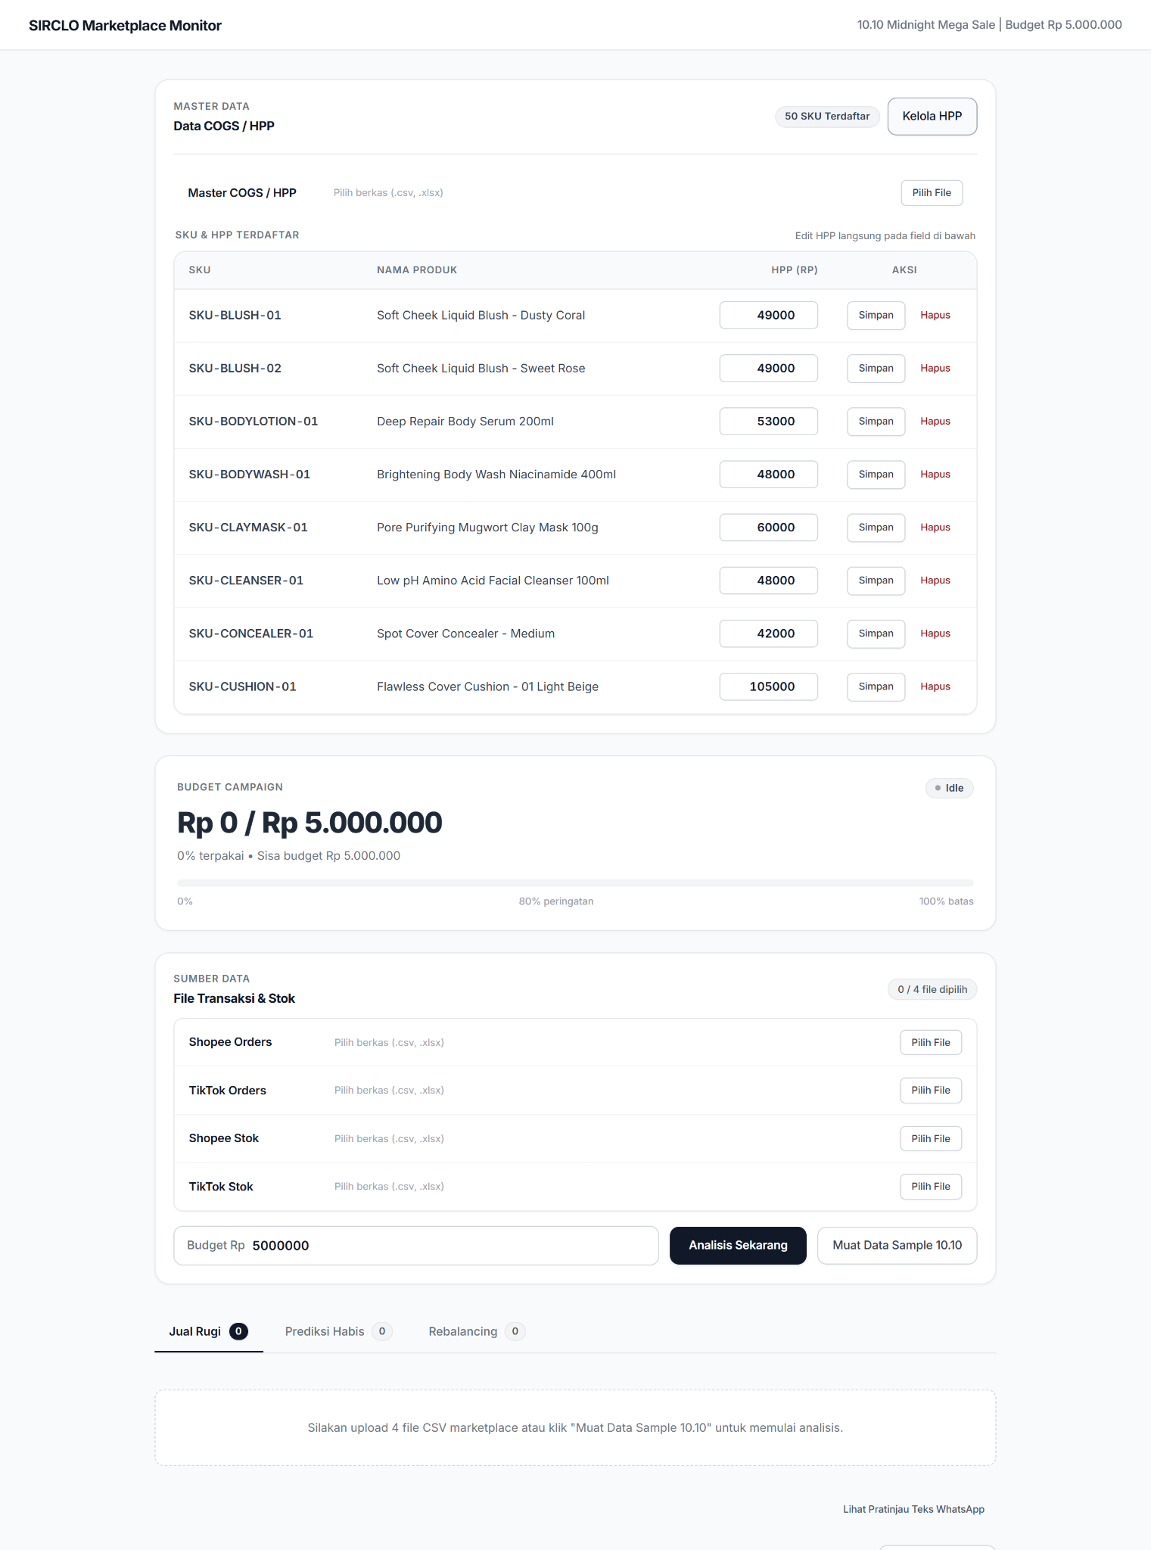
How It Works & Key Elements:
• Persistent Storage: Master HPP (Harga Pokok Penjualan) data is stored in a local SQLite database (50 registered SKUs), persisting across browser reloads.
• In-Place Inline Editing: Operators can adjust the HPP of individual SKUs directly in table input fields and save changes instantly with the [Simpan] button.
• Bulk Master Import: Supports uploading replacement master HPP spreadsheets (.csv/.xlsx) to update the entire catalog in bulk.
• Decoupled Architecture: Cost master data remains safely separated from high-velocity transaction files, preventing accidental data overrides during midnight rushes.

4. State 03: Live Analysis Results — Margin Loss & Budget Tracking
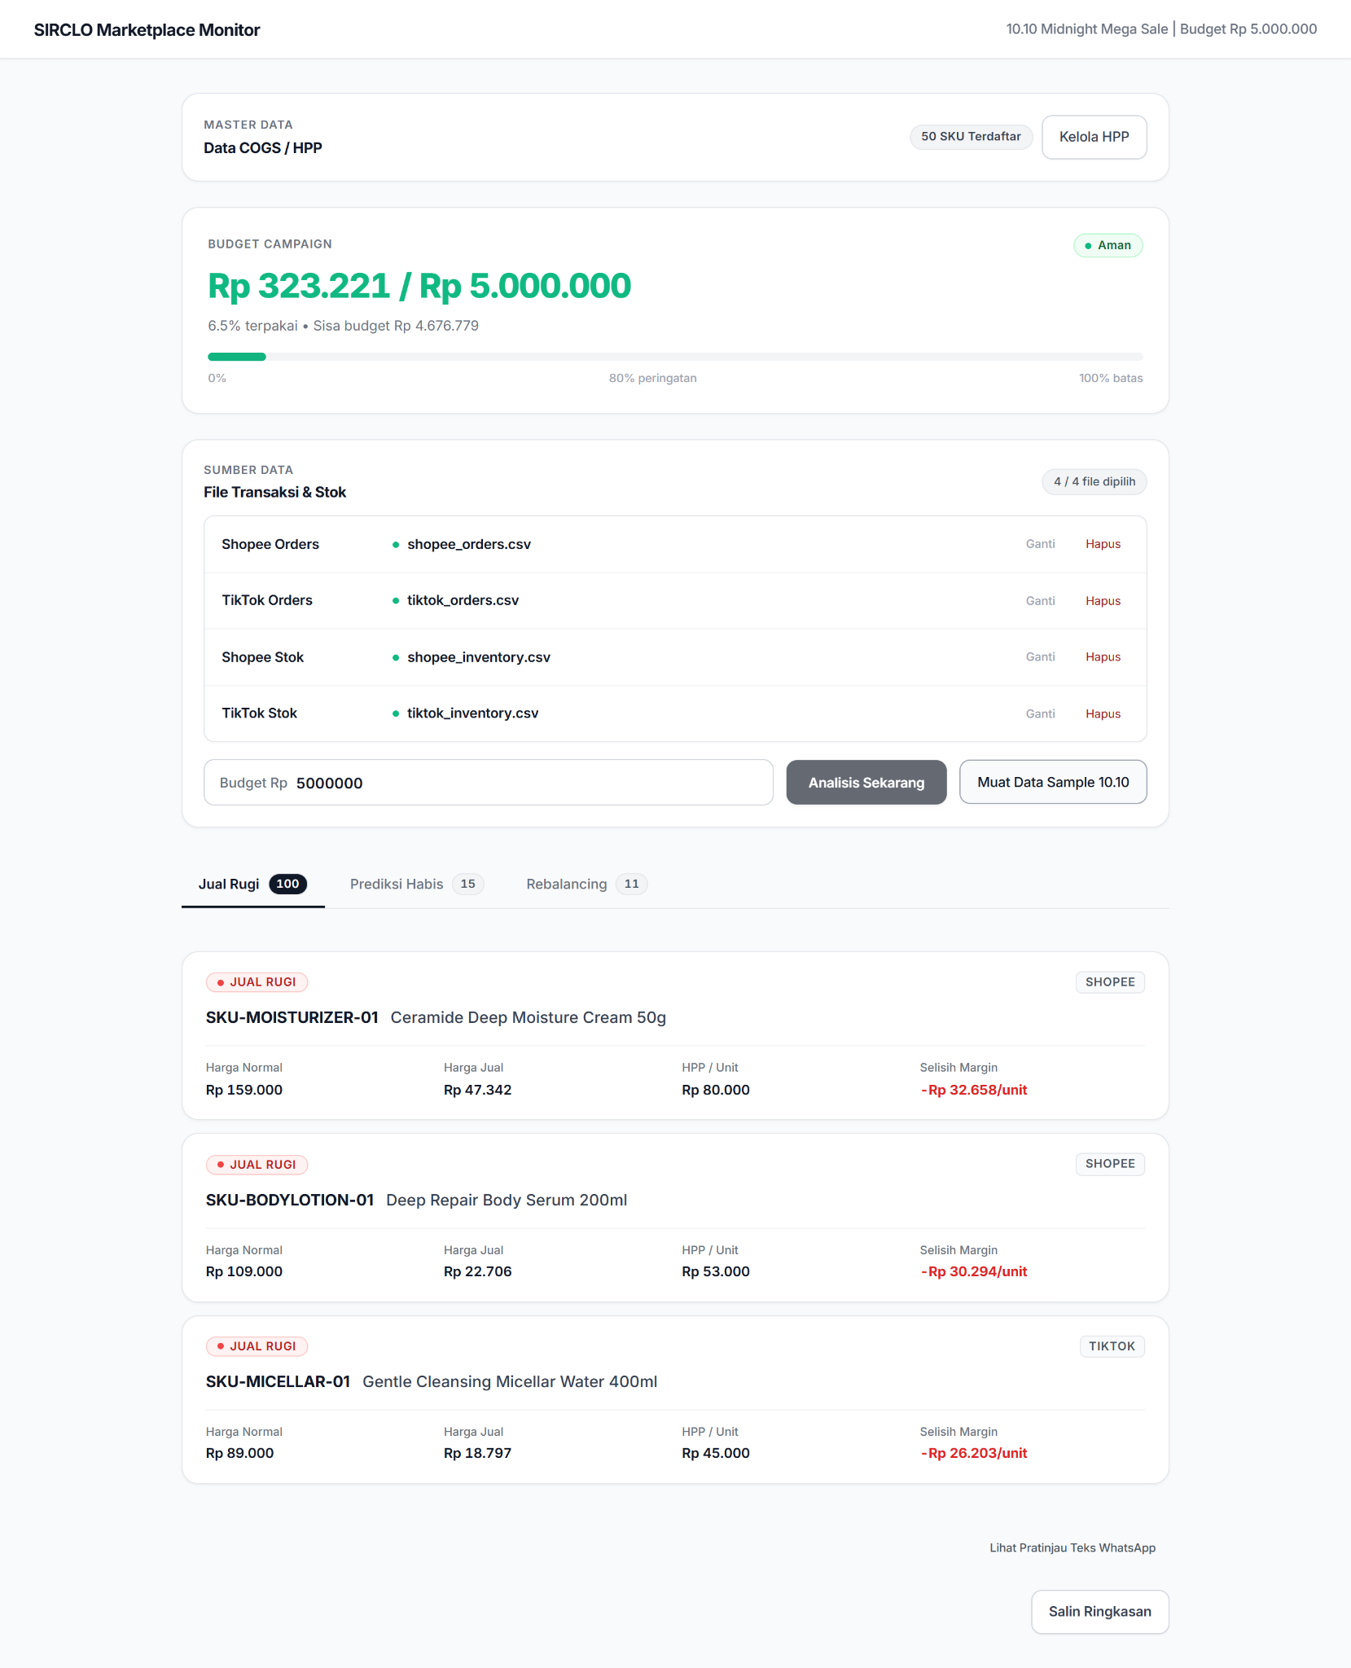
How It Works & Key Elements:
• Dynamic Budget Safe Meter: Calculates cumulative voucher losses (sum of (HPP - actual selling price) * quantity) and compares against the campaign budget (Rp 323.221 / Rp 5.000.000, 6.5% used). Displays dynamic color indicators (Aman, Waspada, or Over Budget).
• Jual Rugi Alert Cards: Every order where actual selling price is below unit HPP is flagged. Sorted with highest unit loss at the top (e.g. SKU-MOISTURIZER-01 losing Rp 32.658/unit).
• Multi-Channel Attribution: Clearly tags whether the loss occurred on Shopee or TikTok Shop, displaying normal price, discounted selling price, unit HPP, and margin delta.
• Tab Counts: Dynamically displays detected issues across tabs (100 Jual Rugi, 15 Prediksi Habis, 11 Rebalancing).

5. Essential Workflow States (Unpictured Features)
While not pictured in the selected screenshots, the following states and capabilities form critical pillars of the system's operational loop:
A. Tab 2 — Prediksi Habis (Run-Rate Velocity & Stockout Forecast)
• Calculates hourly sales velocity (Total Units Sold ÷ Elapsed Hours) per SKU and channel.
• Predicts exact time until stockout (Remaining Stock ÷ Run Rate). Items running out in <2 hours are tagged 'Kritis', 2-6 hours 'Waspada', and >6 hours 'Aman'.
• Zero-Velocity Protection: SKUs with zero sales cleanly display '∞' rather than crashing or showing NaN.
B. Tab 3 — Multichannel Stock Rebalancing Recommendations
• Detects channel stock imbalance: Triggers when marketplace stock is depleted (≤ 5 units) while central warehouse stock is abundant (> 50 units).
• Actionable Recommendations: Automatically calculates optimal transfer batches (e.g. 'Rekomendasi: Replenish Shopee (+100 unit)') so operators can shift inventory before listings get suspended.
C. 1-Click WhatsApp Escalation Workflow
• Per-Item Escalation: Clicking any alert card immediately copies a concise, standardized action alert to the operator's clipboard, complete with SKU, loss per unit, selling price, and HPP, with a 3-second toast feedback ('Pesan aksi disalin'):
[1-CLICK COPIED WHATSAPP ALERT]
ALERT: SKU-MOISTURIZER-01 (Ceramide Deep Moisture Cream 50g) jual rugi -32658/unit di shopee. Harga jual Rp 47342, HPP Rp 80000. Segera cek voucher.
• Executive Summary: The [Salin Ringkasan] button copies a comprehensive broadcast briefing covering overall budget spend, top loss leaders, imminent stockouts, and transfer orders ready for managerial chat groups.
D. Validation, Guardrails & Error States
• Missing Files Guardrail: Prevents partial calculations if fewer than 4 files are uploaded, showing an inline negative error banner.
• Schema Validation: Catches corrupt files or missing headers (e.g. missing 'sku_reference_no' in Shopee Orders).
• Unmapped SKU Warning: If orders include newly added SKUs missing from the COGS database, a warning banner alerts the operator without aborting calculation for the rest of the catalog.
• Rate-Limit Protection (HTTP 429): Enforces a server-side cooldown with live countdown timer ('Tunggu 5s...') to prevent server saturation during multi-operator access.

